**Step by step guide to DialogFlow (API.AI) Part 1 – Introducing the FAQ bot**

[Table of Contents for Step by Step Guide](http://miningbusinessdata.com/step-by-step-guide-to-api-ai/)

This is the first part of a multi-part guide I am writing on API.AI. This series came about as a result of a question I saw on the API.AI forum, where someone asked if there were any step by step guides. When I began learning API.AI, I sometimes felt that many of the online resources do not really take a step by step approach – here, by step-by-step I mean an approach where they focus on one thing at a time as they teach.

The way bot building frameworks are built, it does look like you need to simultaneously learn many different concepts and isolated concepts are not very helpful. So my first goal is to create what I call “microbots” – they are too focused and even a little too contrived to be of much practical use, but they serve as useful resources for learning.

**Requirements**

This is intended as a resource and guide aimed mainly at programmers. At the moment, building moderately complex chatbots is not quite “push button”. As we go further along, I expect that you will be able to write some code on your own to get your bot working.

If you are completely non-technical, you can still follow along for the first three bots I will be building where I will teach you how intents, entities and contexts work. You can also ask your questions in the [API.AI discussion forum](http://discuss.api.ai/). If you are interested in private online coaching, see end of post for contact info.

**The FAQ Bot**

The Frequently Asked Questions bot is one such microbot which may not have too many practical applications. *An FAQ bot simply returns the best resource/post/article on a given website which matches the user’s question.* The FAQ bot is limited on many levels.

1. A search engine can usually do what the FAQ bot can
2. If it only provides “one and done” answers to a user’s question, it is not very conversational. There is nothing chatty about such a bot.
3. It is not likely to be as comprehensive as the search on a website

However, even an FAQ bot can actually be an improvement sometimes. For example, the default WordPress search is not very good when the keywords used are not present in the article. Since the FAQ bot uses natural language processing techniques, it is more likely to use word stems, synonyms and such and still provide good answers when the keyword varies from what is usually seen in the article.

In addition, suppose you have a website where people repeatedly ask the same type of questions. An FAQ bot can actually be very helpful for them since you can make it work for many different variants of the same question.The FAQ bot we will be building will be an FAQ bot for API.AI itself.

# Step by step guide to DialogFlow (API.AI) Part 2 – Preparing the FAQ list

[Table of Contents for Step by Step Guide](http://miningbusinessdata.com/step-by-step-guide-to-api-ai/)

As mentioned in the previous post, we will be building an FAQ bot which will answer questions about API.AI. So the first thing we need is a resource from where we can get answers about API.AI – and we have one ready: the [API.AI documentation](https://docs.api.ai/docs/key-concepts).

**Preparing the FAQ list**

We will look at the different sections in the API.AI documentation, and generate a list of questions that users may have about that section. Since this is for learning purposes and not meant to be exhaustive, we will only consider the high level ideas. We can easily gleam the key concepts by looking at the structure of the API.AI documentation. Here is what the documentation looks like:

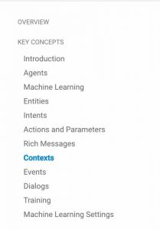

For each section under Key Concepts, we will have atleast one FAQ answer. Our goal here is to anticipate what questions should direct users to which answers (sections) on the documentation.

So we will collect each section that can be a standalone answer, and make a list of links in a table. This is what this list looks like for me:

As you can see, the list of links and FAQ questions is not comprehensive. But the idea is straightforward: for each resource (i.e. a link on the left column of the table) you will be anticipating possible questions and adding them into the corresponding FAQ questions in the right column of the table.

In the next post, we will look at understanding intents based on the FAQ list we prepared.

# Step by step guide to DialogFlow (API.AI) Part 3 – Creating an agent from the FAQ list

[Table of Contents for Step by Step Guide](http://miningbusinessdata.com/step-by-step-guide-to-api-ai/)

Now that we have prepared an FAQ list as mentioned in the previous post, we are ready to create our first chatbot.

Log in to api.ai (you can use your Google account if you want).

### ****Create new agent****

For a fresh account, no agents will be listed. But if you already have some agents created, like mine, you will need to click on the down arrow next to the current agent’s name, and scroll down to the bottom of the list and select “Create new agent”.

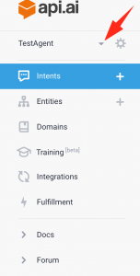

### ****Create a list of intents****

Now it is time to populate the intents. As you do this step, it will become clear what intents are – but there is a section to follow which goes into more detail.

#### 1 Click on the + sign next to the Intents in the left pane to create a new Intent

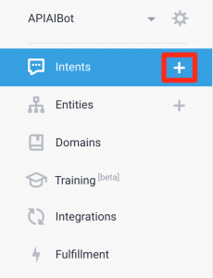

#### 2 Name the Intent

Use the section name as the name of the intent.

#### 3 Add the list of questions

For each item in the right column of the table, add one “User says” entry. Once you are done, your Intent screen should look like below. Ignore the yellow highlights for now.

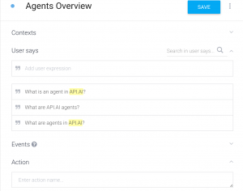

#### 4 Add the link in the Response field

Now take the link on the left hand side of the table and add it to the Response text box. Your screen will look like below.

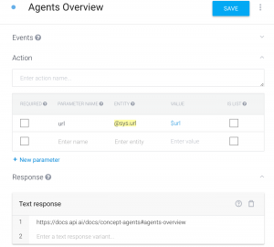

Leave the rest of the fields, like Action and Events, empty.

Repeat steps 1 through 4 for each FAQ link in the table you created from the previous post. When you are finished with all the links, your agent is ready.

### Test the agent by using the interactive console on the right hand side

As you are creating the agent, you can keep testing it by using the interactive console on the right side. For example, here is how my agent responds when I ask a question.

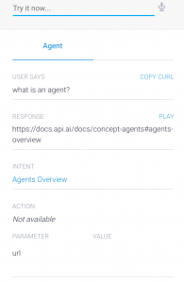

Let us look at this in some detail. First, under User Says, you see what you just typed.

Next, the Response is what the agent will respond with when you deploy it. As you can see, it gives us a link to the API.AI documentation pointing to the definition of agents (as expected).

It also has, under Intent, “Agents Overview” which is the name I gave the intent. So API.AI has determined that the query that the user typed is similar to the User Says phrases which we had used when defining this intent. You should note that the phrase used for testing isn’t an exact match with any of the items in the list of “User says” phrases for that intent, but it is close enough that API.AI can decide that is the intent it should be mapped to.

Finally, it also shows a couple more things such as Action and Parameter, which we will ignore for now.

**Step by step guide to DialogFlow (API.AI) Part 4 – Intent Mapping**

[Table of Contents for Step by Step Guide](http://miningbusinessdata.com/step-by-step-guide-to-api-ai/)

In the previous post, you used the interactive console on the right hand side to test your agent’s responses for different questions from the user.

In this post, I will give an overview of what is happening, and what is the expected behavior.

The main feature of a bot building service such as API.AI is to look at the words typed (or said) by the user, and **map it to a list of expected phrases**. This is called intent mapping. While there is a lot of machine learning logic which goes on underneath the hood to make this happen, for the bot programmer, this is like a black box which works as follows.

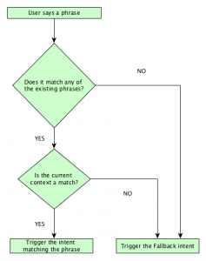Intent Mapping in API.AI

The first condition in the flowchart – “Does it match any of the existing phrases?” is based off the list of “User says” questions you created for the FAQ. API.AI is looking for similarity.

Suppose, the user were to type “What is the meaning of life?”, it will not match any of the “User says” phrases we have used. So the flowchart will select the first (top) NO branch and trigger the fallback intent.

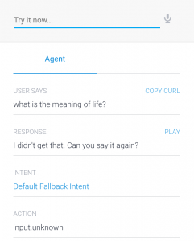

There is also a second condition in the flowchart, as you have noticed. This condition checks if the current context is a match. We will look into contexts in more detail in a later post, but you can think of it as an additional criteria that must be satisfied before an Intent is chosen as the right mapping.

This ends the discussion about our first FAQ bot. The goal of building the FAQ bot was to get a basic idea of what Intents are and how intent mapping works. Next we will be looking at entities.

# Step by step guide to DialogFlow (API.AI) Part 5 – The Wimbledon Finals bot

[Table of Contents for Step by Step Guide](http://miningbusinessdata.com/step-by-step-guide-to-api-ai/)

Hopefully you are familiar with the game of tennis and know something about the Wimbledon tournament, generally considered to be the most prestigious of the Grand Slam tournaments. Even if you are not, you certainly know the concept of a tournament winner and the tournament runner-up.

The WimbledonFinalsBot has only one purpose for its existence. When you ask it “Who was the winner of the women’s Wimbledon 1991?” as an example, it will give you the name of the women’s tennis player who won the tournament that year. Similarly, you can ask the bot about who was the runner up in a particular year. You can also ask the same question for the men’s players. To make it a little easier to create the chatbot, the bot will only provide answers about the tournaments which took place after 1980. We will be using the Wikipedia’s page about [men’s winners](https://en.wikipedia.org/wiki/List_of_Wimbledon_gentlemen's_singles_champions) and [women’s winners](https://en.wikipedia.org/wiki/List_of_Wimbledon_ladies'_singles_champions) for reference.

One thing you will notice, when comparing with the FAQ chatbot, is that the answer supplied by the bot has to be dynamic. This is where the concepts of entities comes into the picture.

Here is how entities are defined in API.AI’s documentation:

*Entities represent concepts and serve as a powerful tool for extracting parameter values from natural language inputs.*

The broad definition of entities is that they are concepts. For a programmer, a good way to think about entities is that they are instances of a class.

Consider the ubiquitous dropdown around the web that shows a list of country names. Here, the entity is “Country”. The actual values you see in that dropdown are the entity values.



A second analogy that programmers can relate to is the concept of the placeholder when you are printing strings. This is actually a very useful analogy, because when you are interacting with API.AI entities you will be using syntax which will look familiar if you are already comfortable using placeholders in your programming.

**Step by step guide to DialogFlow (API.AI) Part 6 – Populating the entities**

[Table of Contents for Step by Step Guide](http://miningbusinessdata.com/step-by-step-guide-to-api-ai/)

In the previous post, we learnt a little about the WimbledonFinalsBot (henceforth WFBot) we will be building.

You will start by creating a new agent just like for the FAQ bot. Once you have created an agent, the next step will be to declare the Intents. If you remember from the previous posts, the intents should be the different phrases you expect your user to ask.

In our case, we have only 4 intents.

1. Who won the men’s tournament in year X?
2. Who won the women’s tournament in year X?
3. Who was the women’s runnerup in year X?
4. Who was the men’s runnerup in year X?

However, before we can declare our Intents, we should first declare our entities. I mention the Intents first because I am establishing the motivation as to what kind of questions the user will ask the bot, so we can better understand how to declare and populate our entities.

Click on the + sign next to the Entities in the left pane.

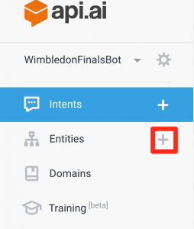

I am going to populate the values for the men’s winners in the first step. Take a look at what happens when I type mens winners into the entity name.

https://miningbusinessdata.com/wp-content/uploads/2017/03/entity_space_error-300x50.png

API.AI complains that there should be no spaces in the name. As you will see later, this will be an important constraint which will help us when we use this entity later.

So I will call this entity mens-winners (no spaces).

https://miningbusinessdata.com/wp-content/uploads/2017/03/entity_no_error-300x49.png

The next step is to fill out the values.

There is the slow way – you can type out the values one by one. But you can also import these values if you can get the data in CSV or JSON format.

To do this, click on the three vertical dots next to the save button, click on “Switch to raw mode”, and fill out the values in the format of your choice. I have uploaded the input in the CSV format below.

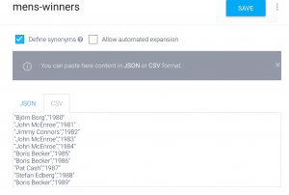

Next, we will see how to declare the intents so we can query this data.

# Step by step guide to DialogFlow (API.AI) Part 7 – Declaring Intents with Entities

[Table of Contents for Step by Step Guide](http://miningbusinessdata.com/step-by-step-guide-to-api-ai/)

In the previous post, we populated the mens-winners entity with a list of values. When you see the Entity in the Editor mode (as opposed to the raw mode you used for uploading CSV), you will see the following:

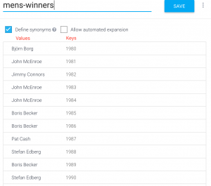

If you notice, I have added the column names Keys and Values to annotate this image. I think of this as a sort of “inverted dictionary” format. The first word you will type is the value of the dictionary (who won?), and the synonyms you will define will contain exactly one item, which is the key of the dictionary (which year). That is, winner[1987] = Pat Cash.

As we go further, you will see why we need to declare it in this inverted dictionary like format.

**Declaring the Intent**

I will start by declaring a single intent corresponding to the entity we have created. We want to know the winner of the Wimbledon’s mens title in a particular year.

So create a new Intent, and – **this is very important** – click on the apostrophe at the beginning of the User says textbox and toggle it to the @ sign.

https://miningbusinessdata.com/wp-content/uploads/2017/03/template_mode-300x46.png

When you click and toggle into the template mode, the apostrophe will turn into an @ sign. More importantly, you will be able to refer to the entities you have already created – by using the @ prefix you will see autocompletion options.

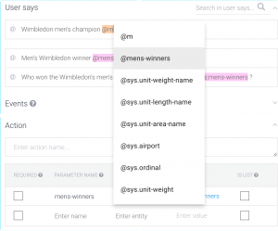

Now type out the following into the User says box (in three different User says boxes), while remembering to keep the text box in template mode (the default is example mode which has the apostrophe at the beginning)

*Wimbledon men’s champion @mens-winners:mens-winners*

*Men’s Wimbledon winner @mens-winners:mens-winners*

*Who won the Wimbledon’s men’s championship in @mens-winners:mens-winners ?*

If you remember from the previous FAQ bot, the goal is to create many variants of the same question. This helps API.AI understand the patterns which could be used when people are asking about the same thing.

In the section called Response, input the following:

*The winner of the $mens-winners.original men’s Wimbledon championship was $mens-winners*

**Testing what we have till now**

Now let us go to the test console and try the following query, you can see that the response is as expected.

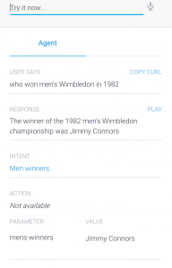

Let us look at the format of the Response we just typed out. When we refer to $mens-winner, API.AI will use it as a placeholder for the “Value” of the entity. And if you remember the column names annotated from the picture above, when the user asks the question “who won men’s Wimbledon in 1982”, a few different things are going on under the hood.

In the next part, we will look “under the hood” and see what is happening.

# Step by step guide to DialogFlow (API.AI) Part 8 – Completing the WFBot Intent definitions

[Table of Contents for Step by Step Guide](http://miningbusinessdata.com/step-by-step-guide-to-api-ai/)

You have seen that for the first type of question (who won the men’s Wimbledon in year X?), the agent is able to provide the correct response. All that is left to do to complete the bot is to

a) populate the remaining entities (womens-winners, men-runnersup, women-runnersup)

b) declare the corresponding intents

### Populate remaining entities

You can add three more entities, name them womens-winners, men-runnersup and women-runnersup respectively. See the picture for example for what the women-winners entity declaration looks like.

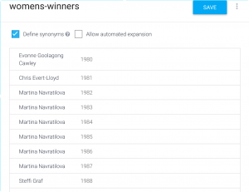

Do the same for men-runnersup and women-runnersup

### Declare the remaining intents

For women’s winners, here is what the Intent declaration looks like. You can also see that the correct response is provided in the interactive console on the right.

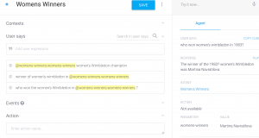

The Intent response is declared as follows:

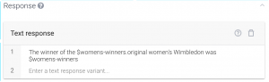

By following the same steps for men’s and women’s runner up, you should have the complete WFBot.

Also, do you notice the question mark character next to the year in the agent’s response on the right. This is one of the peculiarities of the way systems like API.AI work today. When entities match, they only need to be close enough to already declared entities. At the same time, the value used in the agent’s response is  $womens-winner.original, meaning it will simply output what it matched. This is yet another reason that I believe the examples are a little impractical – although they illustrate the point. (Note: You can improve this response and omit the question mark by writing some code on the backend. That is an advanced topic at this point).

# Step by step guide to DialogFlow (API.AI) Part 9 – how Intent Mapping works under the hood

[Table of Contents for Step by Step Guide](http://miningbusinessdata.com/step-by-step-guide-to-api-ai/)

In the previous post you saw how the question “who won men’s Wimbledon in 1982” was correctly answered by the agent. At this point, it would be a good idea to take a little break from building the agent to go into a little detail about what is happening under the hood. It is my view that this knowledge will help you in three different ways.

#### 1 Bot behaves unexpectedly

When your bot doesn’t behave as expected (which will happen sooner or later), knowing some of the underlying concepts can help you better understand what is going on

#### 2 Decide how much custom code you need

As a result of 1, you can often realize the limitations of a bot building platform such as API.AI and decide how much of the code you wish to move outside of the agent and into your custom code

#### 3 Reverse engineering the agent to improve performance

This knowledge will also help you tweak some settings which are at your disposal. Machine Learning, which usually powers these chatbot systems today, is something of a black box. But you can still reverse engineer a few things to improve the results.

**The AI in an API.AI chatbot has two tasks:**

**a) map the phrase to an intent which has already been created, and**

**b) extract any relevant entities.**

When the user types a sentence, it looks at the sentence structure and tries to determine if the sentence structure is a close match to a programmer defined phrase. If one of the programmer-defined phrases in the Intents (let us call them predefined phrases) contains an entity placeholder (the one following the @ symbol), and what the user says also contains an entity value, that is a clue for API.AI (and other bot frameworks) that the user has said something matching one of the predefined phrases.

In the same way, if the remainder of the sentence (excluding the entity) is similar to a predefined phrase, that is ALSO a clue for a match.

As you might imagine, when these two happen in tandem (structural similarity and matching entity value), then API.AI can predict with much greater confidence that the user’s message matched one of the intents. The exact steps for determining this is the secret sauce for any bot framework.

When the user says something completely unrelated, your bot should also figure that out and should trigger the Fallback intent (introduced in [Part 4](http://miningbusinessdata.com/step-by-step-guide-to-api-ai-part-4-intent-mapping/)).

The chatbot does not have any other kind of intelligence. For example, it cannot look at the history of conversation it had with a user and make inferences. Look at a discussion I had on the [API.AI forum](https://discuss.api.ai/t/machine-learning-capabilities-of-the-bot/5180) for an example.

# Step by step guide to DialogFlow (API.AI) Part 10 – The Vending Machine Bot

[Table of Contents for Step by Step Guide](http://miningbusinessdata.com/step-by-step-guide-to-api-ai/)

So we have seen two fundamental concepts of a chatbot framework – namely Intents and Entities.

A third important concept is the idea of context. To lay the groundwork for explaining contexts, I will start by describing the Vending Machine bot (VMBot for short).

Think of the vending machine bot as a spoken language interface for the vending machine. This is a limited vending machine, in that it sells exactly two products – Ruffles and Skittles. And you can only insert quarters into the machine. The Skittles costs 25c and the Ruffles costs 50c.

As you use the vending machine bot, you can say one of the following:

1. Add a quarter
2. Ask for a refund
3. Buy a Skittles
4. Buy a Ruffles

The state diagram of the vending machine would look like this:

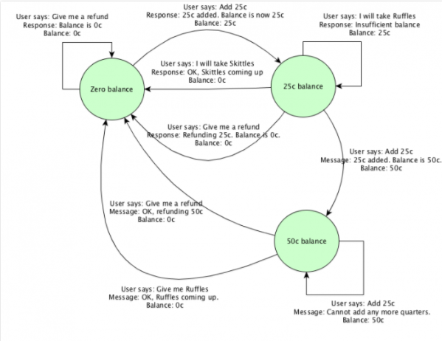

Here is a flowchart I created using XMind which gives you a representation which is closer to the actual conversation which takes place. You can get the actual mindmap (the .xmind file) from the [MBD Bonus Pack](https://gum.co/PRzZy) if you are interested. In the MBD Bonus Pack, you can see this under the [MM-VendingMachine] folder.

###### [How to read this chart?](http://miningbusinessdata.com/read-conversation-flowcharts-tutorials-site/)

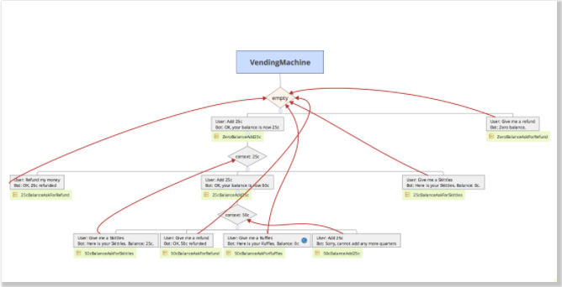

# Step by step guide to DialogFlow (API.AI) Part 11 – Using contexts to maintain state

[Table of Contents for Step by Step Guide](http://miningbusinessdata.com/step-by-step-guide-to-api-ai/)

In the last post we saw how the vending machine bot works. The main difference between the previous two chatbots (FAQ Bot and WimbledonFinalBot) and the current one is that we need to keep track of the user’s previous messages so that we can use that to decide the current action.

Suppose the user says “Add 25c”. Is the current balance 25c or 50c? It depends! If the current balance is already 25c, then the final balance becomes 50c. If the current balance is 0c, then the final balance becomes 25c. The way we know what the current balance is, is by using contexts. In other words, we use contexts to **maintain state**.

At the start of the conversation, if the user says”Add 25c”, we will be setting the “output context” of the intent to a string called 25c (since current balance is 0c). Now the output context is used as the “input context” for the next intent. That is, if the input context is already 25c, and the user says “Add 25c” we will be setting the output context of the intent to a string called 50c.

Using this combination of input and output contexts, you can see that it now becomes possible to maintain state even for more complex scenarios.

Here is a flowchart which shows how we set the input and output contexts for the Intents.

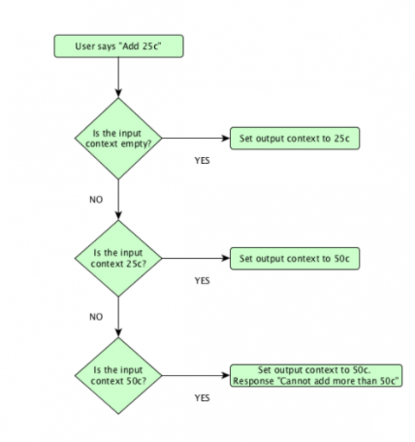

The nice thing about API.AI is that the Intents are created in such a way that we can set input and output contexts on our Intents to achieve this result. We will see how in the next part.

**Step by step guide to DialogFlow (API.AI) Part 12 – Using input and output contexts to manage state**

[Table of Contents for Step by Step Guide](http://miningbusinessdata.com/step-by-step-guide-to-api-ai/)

We saw in the previous part that we would like to maintain the state of the current balance in the vending machine so that we can decide what the final balance would be when the user adds another 25c.

You need to remember that the Intent for both zero balance and 25c balance will be defined using more or less the same set of User says phrases (given that in both cases the user will be saying more or less the same phrase). The way API.AI will decide which Intent to trigger will be based on what the Input context is, as we saw in the flowchart of the previous part.

Here is the Intent for adding a quarter at zero balance:

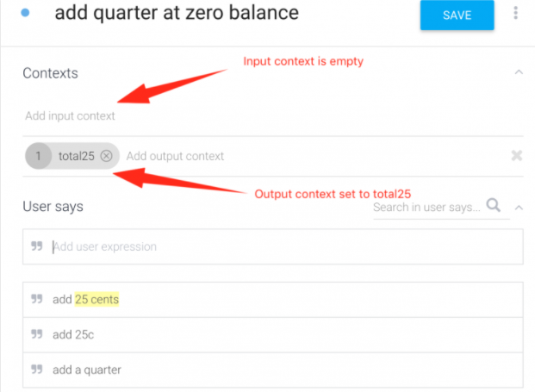

There are three things to note here:

1. The input context is empty (indicating start of conversation where balance is zero)
2. The output context is set to total25 (a string value representing the state)
3. There is a 1 on the left of the total25. That is the context lifespan, whose default value is 5. I recommend setting it to 1 and tracking the value carefully (I wrote about this before in my article about [context lifespans](http://miningbusinessdata.com/optimal-context-lifespan-in-api-ai/))

The Intent definition for adding a quarter at 25c balance will have similar phrases, except for the input and output contexts.

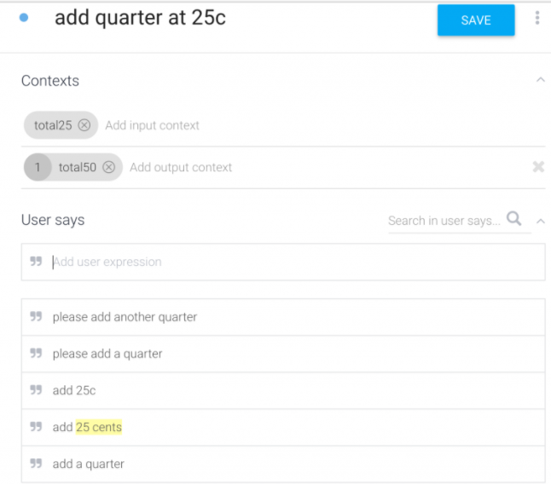

By using the same idea, you should be able to fill out the remaining Intents for the vending machine chatbot. You can [interact with the vending machine chatbot I built at this link](https://bot.api.ai/cc90a873-3952-451c-b18d-63ce2a039589).

As I interacted with the chatbot, I noticed that sometimes the response is wrong because the Intent mapping is incorrect. If you face a similar issue, you can provide more User says examples closely matching the request and that should usually fix the problem.

# Optimal context lifespan in DialogFlow (API.AI)

Contents [[hide](https://miningbusinessdata.com/optimal-context-lifespan-in-api-ai/)]

* [1 Contexts](https://miningbusinessdata.com/optimal-context-lifespan-in-api-ai/#Contexts)
* [2 Lifespan of a context](https://miningbusinessdata.com/optimal-context-lifespan-in-api-ai/#Lifespan_of_a_context)
* [3 The optimal value](https://miningbusinessdata.com/optimal-context-lifespan-in-api-ai/#The_optimal_value)
  + [3.1 The best conversations tend to meander](https://miningbusinessdata.com/optimal-context-lifespan-in-api-ai/#The_best_conversations_tend_tomeander)
  + [3.2 The machine learning is good, but not perfect](https://miningbusinessdata.com/optimal-context-lifespan-in-api-ai/#The_machine_learning_is_good_but_not_perfect)
  + [3.3 Don’t forget the first step in voice to text conversion](https://miningbusinessdata.com/optimal-context-lifespan-in-api-ai/#Don8217t_forget_the_first_step_in_voice_to_text_conversion)
  + [3.4 Pre-existing domains can add unexpected complexity](https://miningbusinessdata.com/optimal-context-lifespan-in-api-ai/#Pre-existing_domains_can_add_unexpected_complexity)
  + [3.5 The implicit state diagram stays deterministic](https://miningbusinessdata.com/optimal-context-lifespan-in-api-ai/#The_implicit_state_diagram_stays_deterministic)
* [4 But I need to do more work to keep track!](https://miningbusinessdata.com/optimal-context-lifespan-in-api-ai/#But_I_need_to_do_more_work_to_keep_track)
* [5 Exceptions](https://miningbusinessdata.com/optimal-context-lifespan-in-api-ai/#Exceptions)

Note: this is a somewhat advanced topic, and certainly a bit opinionated. I wouldn’t recommend beginners get into this article until they have built at least a toy bot and experienced all the features in API.AI

### Contexts

If you are building bots using API.AI, you are probably aware of contexts. They are used to maintain state. For the express purpose of state management, I find their implementation quite fascinating simply because they have this concept of “lifespan”.

### Lifespan of a context

What is the lifespan of a context you ask? It is the number of “steps” for which a context is alive. As your user interacts with your bot, the remaining lifespan keeps ticking down by 1 per interaction until it hits zero and becomes inactive.

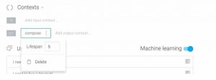Source: https://api.ai/blog/2015/11/23/Contexts/

While the default value is set at 5, I suggest you immediately change it to the optimal value.

### The optimal value

And the optimal value, in my view, is 1. Here are the reasons.

#### The best conversations tend to meander

What I mean is, the bot asks the user a very pointed question, such as “OK, so how many red roses would you like to buy?”

To which the user says, “I am not sure. How much per rose?”. Now if you didn’t expect the user to ask this question, you now have a ticking lifespan clock and you better get the answer you want out of the user before the remaining lifespan goes to zero.

I don’t suggest designing bots with a strange constraint of trying to get the user to the right answer within a given amount of tries. The user is not playing a game of hangman with your chat bot, and the conversation will turn weird very fast if you enforce such constraints.

#### The machine learning is good, but not perfect

In other words, sometimes the user does give you a variant of the expected answer, but it is not recognized as a defined intent. I would propose this is actually a worse outcome than when the user actually typed in something unrelated. Why? Simply because whatever you are going to say to “recover” from this error, is very likely to further confuse the user who had typed in a perfectly reasonable answer already.

#### Don’t forget the first step in voice to text conversion

This is related to my previous point, of course. Remember, there is a small probability that the user’s words were incorrectly translated into text. In that case, you run into the same issue if you suggest that the user may have been on the wrong track while keeping a lifespan clock ticking.

#### Pre-existing domains can add unexpected complexity

I talked a little about this in my article on [building a cricket stats chatbot with API.AI](http://miningbusinessdata.com/building-a-sports-stats-chatbot-using-api-ai/). The issue here is that there are pre-existing domains for which API.AI already populates entities. A good example is the name Steve Smith, who is a popular cricket player with a very common last name. API.AI identifies the Smith as a common name, but doesn’t do a good job of mapping to a user-defined entity called “Steven Smith”. It seems to think they are separate and extracts Smith out as a predefined entity and thinks the word Steve should just hang there at the end of the sentence, basically mapped to nothing.

Maybe you argue it is doing the right thing. I don’t think so, but even if it were, this is the kind of silent failure which is sure to mess up your context lifespan.

#### The implicit state diagram stays deterministic

Using contexts, it is possible to translate any state diagram based conversation flow into a chatbot. However, the state diagram becomes much harder to reason about if you are having lifespans greater than 1 because now you have effectively two different states that your diagram could be in at once. Again, don’t make your chat bot any harder to reason about than it already is.

### But I need to do more work to keep track!

Yes, you do. And that is great!

You see, one of the big issues I have seen with all the chat bot building frameworks is the degree of non-determinism surrounding them. In other words, what is considered AI today is very opaque and not at all easy to reason about. (This should by itself be another blog article someday). Don’t make it even harder for yourself by having non-deterministic context lifespans.

And you don’t have to take this statement at face value. Just check out the [API.AI forum](http://discuss.api.ai) and see how many people get flummoxed by the behavior of intent mapping.

### Exceptions

Are there any exceptions? No.

I mean, I am sure there are some, although I would still recommend you try to rewrite that logic.

Have you had success with keeping lifespan greater than 1? I would love to know your thoughts in the comments.

# Step by step guide to DialogFlow (API.AI) part 13 – Webhooks

[Table of Contents for Step by Step Guide](http://miningbusinessdata.com/step-by-step-guide-to-api-ai/)

While the previous example bots were all self-contained (in the sense that all code was executed on the API.AI’s service), you will make use of webhooks when you wish to write custom logic which is not supported by API.AI.

My view is that it is unlikely you can build a very functional bot without using webhooks. The best example for learning about webhooks is the [API.AI’s weather agent](https://docs.api.ai/docs/webhook#webhook-example)

Update July 24th 2017:

API.AI recently updated all their webhook documentation to use the Google Cloud. While the comparison between Google Cloud and Heroku (the previous cloud service which was used for webhook demos) is an article by itself, for now I will just update the above statement. The easiest way (and thus probably the best way) to get started with webhooks right now is to use Heroku, and you can [*refer to my tutorial*](http://miningbusinessdata.com/api-ai-tutorial-getting-started-webhooks-heroku/) on this topic instead of the documentation above.

### Extending the Vending Machine bot

Here is a simple thought exercise. Pretend that the Vending Machine bot we saw previously had the facility to add either a quarter, or a nickel, or a dime. Now imagine the number of states we would have had to handle (basically a state for every multiple of 5, upto 50). Instead of having that combinatorial explosion of states, we could simply write some custom logic which would compute the total amount added and have far fewer states.

After implementing the weather agent example, you can try creating some custom code behind a webhook to build out this more full-featured vending machine bot.

In the next part, we will look at another interesting example bot to connect the dots on what we have learnt till now.

# Step by step guide to DialogFlow (API.AI) part 14 – The florist bot

[Table of Contents for Step by Step Guide](http://miningbusinessdata.com/step-by-step-guide-to-api-ai/)

One of the examples already provided in the API.AI documentation is an example bot for a florist shop. I really like this example as a teaching tool because it covers so many different features that you will use as you are building out your chatbots. But the biggest reason why I like this example is that someone made the effort to post the agent’s ZIP file online so you can download it, create your own agent with it and play around to get a better picture of the different concepts.

### Flowchart

In the excellent book [Bot Business 101](https://www.amazon.com/gp/product/B01NBU30DA/ref=as_li_qf_sp_asin_il_tl?ie=UTF8&tag=aravindmc-20&camp=1789&creative=9325&linkCode=as2&creativeASIN=B01NBU30DA&linkId=ab184db08c0fa1f793c4e5b50beb3454), Ekim Kaya mentions the following:

“My biggest recommendation is to have a very, very detailed conversational flow as to how the scenario will be executed….Intent management is not easy and if it does not work on paper, it will not work on the computer either.”

Ekim has been in the bot business for a long time, and you can see from the book’s reviews that he knows what he is talking about.

So designing the bot’s conversation flow in a flowchart is a good idea.

### Florist shop flowchart

The florist shop example from API.AI has a detailed conversational flowchart:

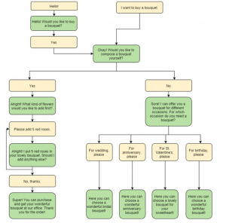Source: https://api.ai/blog/2015/11/23/Contexts/

### Florist shop conversation flowchart using XMind

I have re-created a flowchart for the florist chatbot using XMind. There are some advantages of using XMind for creating the conversation flowcharts for your chatbot. For example by adding input and output contexts into the flowchart itself (but distinguishing them via a different shape), you can add a ton of detail to the conversation flowchart without making it too difficult to follow. I will write about conversation flowcharts in detail in a future article.

If you would like to get a copy of the mindmap file (.xmind format) – you can get it from my [MBD Resources](https://courses.miningbusinessdata.com/courses/mbd-resources) course (chapter 11). I have left out a couple of branches for clarity.

###### [How to read this chart?](http://miningbusinessdata.com/read-conversation-flowcharts-tutorials-site/)

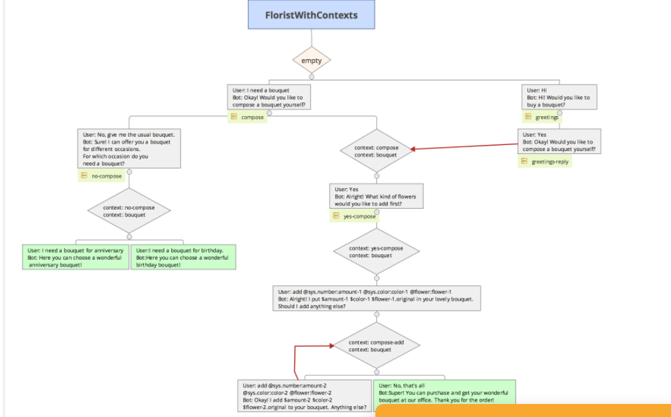

# Step by step guide to DialogFlow (API.AI) Part 15 – Identifying intents in the florist bot

[Table of Contents for Step by Step Guide](http://miningbusinessdata.com/step-by-step-guide-to-api-ai/)

In the previous post, we saw the flowchart for the florist bot.

### Identifying entities

The process for identifying entities, in my view, is to start looking for the nouns in your flowchart. In the case of the florist bot, we see the following: red roses, and nouns for events (wedding, anniversary etc.). For this particular case, only the red roses (in general, flowers) are defined as entities since the event-based nouns are only used for static responses in the flowchart.

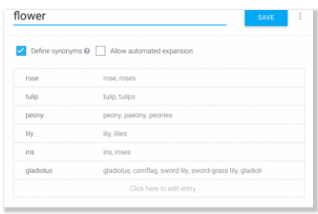

Now let us look at the different intents we need to define.

### Identifying Intents

In the flowchart, all the yellow boxes where the user says something is an intent. There are 11 such yellow boxes.

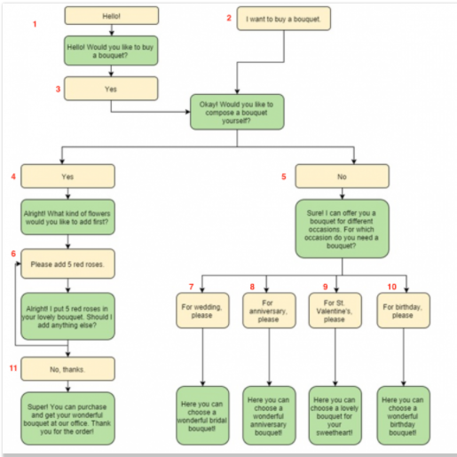

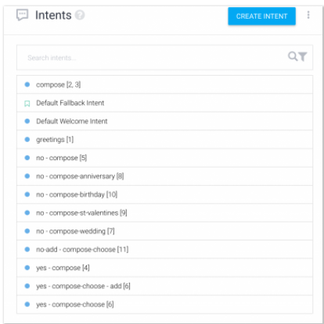

I have mapped out the Yellow boxes in the flowchart to the list of intents in the florist zip file.

You should note a couple of things:

1. There are two numbers mapped to the top Intent. This is because you can combine multiple possible phrases into a single intent. (User says “Yes” or User says “I want to buy a bouquet” which both have the same intention)
2. A single number can also become two intents. E.g. Box number 6 is defined using two different intents. Why is this the case? It is because this is the place in the flowchart where you have a loop. And a loop is usually constructed with an intent for the case where the loop has not yet been entered, and another one for the case where the loop has already been entered. If you remember our discussion about contexts, you might remember that they are usually used to distinguish states in these scenarios.

There are also other things you can analyze which will help you decide on the intents.

Does your flowchart have a merge? For example, yellow boxes 2 and 3 merge into a single green Response. This is the reason why they have been declared as a single intent. If you don’t yet have any contexts set, you can combine the two merging yellow boxes into a single intent.

Does your flowchart have splits? For example, the previous green box for 4 and 5 is splitting based on the two possible responses (Yes or No). In those cases, you will usually have 1 intent per splitting branch.

Does your flowchart have loops? For example, there is a loop after box 6. You might notice that it is also like a split – except that one of the splitting branches loops back. As a result, you have two intents to represent the loop (the last 2 intents in the list).

In the next post, we will talk about contexts in the “context” of the florist bot.

# Step by step guide to DialogFlow (API.AI) Part 16 – How contexts help intent mapping

[Table of Contents for Step by Step Guide](http://miningbusinessdata.com/step-by-step-guide-to-api-ai/)

In the previous post, we looked at how the flowchart of the florist bot can be used to understand the entities and intents you will use to create your API.AI agent.

In this post, we will take a closer look at the contexts which have already been defined in the agent and how they influence the agent’s behavior.

### Distinguish between two different intents where the user phrase is the same

In the [florist bot flowchart](http://miningbusinessdata.com/step-by-step-guide-to-api-ai-part-15-identifying-intents-in-the-florist-bot/), you will notice that boxes 3 and 4 have the same user phrase (“yes”). So if the user says “Yes” in the middle of the conversation, how will the bot know what is the next step?

Now, if we take a look at the intents corresponding to these boxes, we will get a better idea.

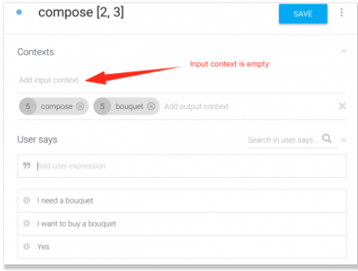

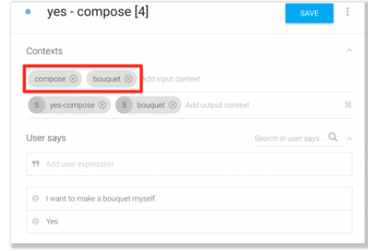

For intent corresponding to box 3, there is **no input context**.

For intent corresponding to box 4, **compose and bouquet** have already been defined as the input context.

Now let us look at the different contexts used in the entire list of entities defined in the agent ZIP file.

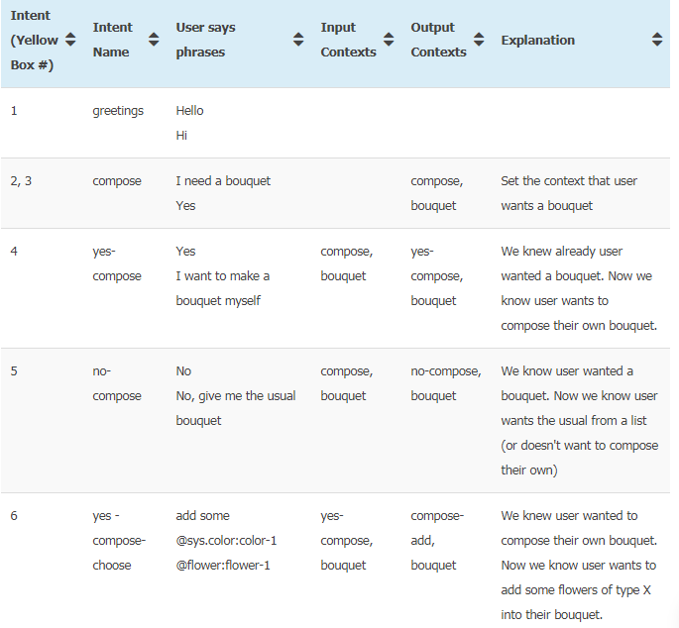

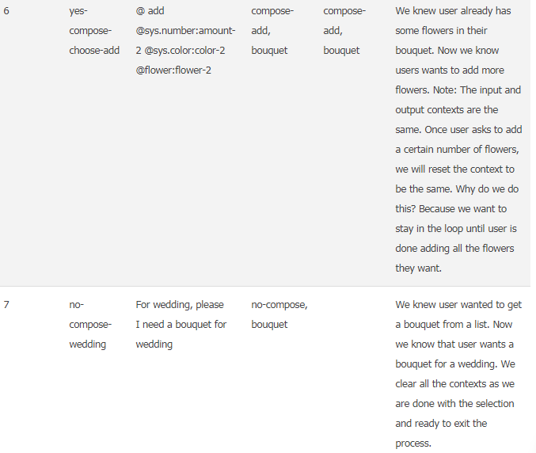

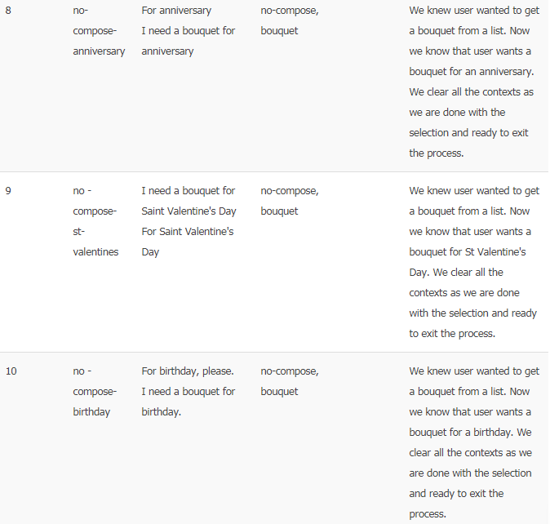

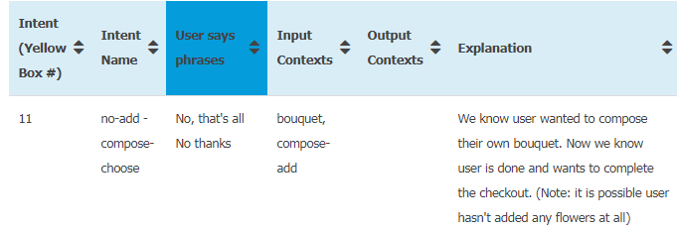

# Step by step guide to DialogFlow (API.AI) Part 17 – Follow up intents

[Table of Contents for Step by Step Guide](http://miningbusinessdata.com/step-by-step-guide-to-api-ai/)

Recently, API.AI announced a new feature called [Follow Up Intents](https://docs.api.ai/docs/concept-intents#follow-up-intents). You can add them from the Intents view and they allow you to create a hierarchy of intents.

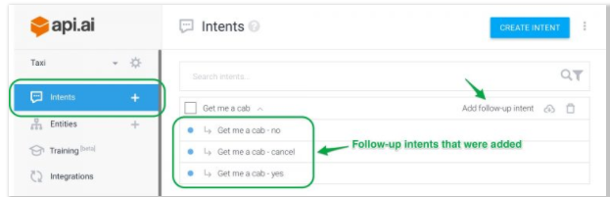

What are the advantages? And when do you need them? Let us take a look.

### What are follow up intents?

Follow up intents, as their name suggests, are intents you define to be a child intent of an existing intent. Creating a follow up intent is quite straight-forward. As you hover your mouse on any intent in the Intents view, you will see a link which says “Add follow-up intent”. Clicking on the link gives you the following options:

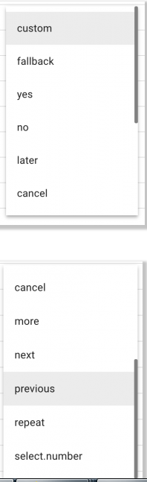

If you choose Custom fallback intent, you will be allowed to enter your own “user says” phrases. If you choose any of the other choices, you will be provided with a prepopulated list of appropriate “user says” phrases which you can then edit to your liking. For example, this is what the prepopulated list for “Yes” choice looks like:

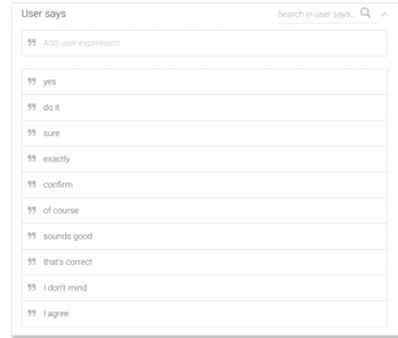

### Can we improve our previous bots with follow up intents?

#### FAQ Bot

[The FAQ bot](http://miningbusinessdata.com/step-by-step-guide-to-api-ai-part-1-introducing-the-faq-bot/) is too simple to need a follow up intent, given that it acts more or less like a search engine with questions followed by answers, without any need for context.

#### Wimbledon Finals Bot

Similar to the FAQ bot, the [Wimbledon Finals bot](http://miningbusinessdata.com/step-by-step-guide-to-api-ai-part-5-the-wimbledon-finals-bot/) also functions like a question and answer bot (although it includes and introduces the concept of entities). Here too, the bot is too simple to need follow up intents.

#### Vending Machine Bot

The simple [Vending Machine Bot](http://miningbusinessdata.com/step-by-step-guide-to-api-ai-part-10-the-vending-machine-bot/) we created to understand contexts is definitely a use case for follow up intents. However, this is also because we had a somewhat oversimplified vending machine. Still, you can rewrite the vending machine bot to use follow up intents and simplify the chatbot quite a bit. In a future post of this series, I will discuss how to rewrite the vending machine bot using follow up intents.

#### The weather bot (Webhooks)

The [weather bot](http://miningbusinessdata.com/step-by-step-guide-to-api-ai-part-13-webhooks/) introduced the concept of webhooks, and while there is a fair amount of code which goes into its business logic, the actual user facing portion is still a simple question and answer interface and doesn’t need follow up intents.

#### The florist bot

Here, it gets a little more interesting. On first glance, when you look at the flowchart for the [florist bot](http://miningbusinessdata.com/step-by-step-guide-to-api-ai-part-14-the-florist-bot/), you might think follow up intents are very useful for the florist bot and should simplify the overall process a lot. There is a small catch however.

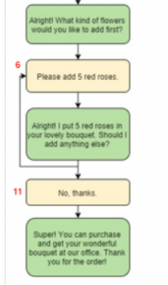

The problem is with the box marked number 6. It is actually a while loop, and using follow up intents, you cannot create a while loop where you don’t know how many times you will be entering the loop.

In the next post, we will consider a use case which is almost perfect for the follow up intents.

# Step by step guide to DialogFlow (API.AI) Part 18 – Dichotomous key bot

[Table of Contents for Step by Step Guide](http://miningbusinessdata.com/step-by-step-guide-to-api-ai/)

One of the best use cases which illustrates the use of follow up intents is the dichotomous key bot. Here is a [definition of the Dichotomous Key](https://oregonstate.edu/trees/dichotomous_key.html):

*A dichotomous key is a tool that allows the user to determine the identity of items in the natural world, such as trees, wildflowers, mammals, reptiles, rocks, and fish. Keys consist of a series of choices that lead the user to the correct name of a given item. “Dichotomous” means “divided into two parts”. Therefore, dichotomous keys always give two choices in each step.*

### Dichotomous Key Bot

We will create a dichotomous key bot for identifying vertebrates. This is what a flowchart for the dichotomous key looks like (for a much better looking flowchart, [refer to the source](http://ib.bioninja.com.au/standard-level/topic-5-evolution-and-biodi/53-classification-of-biodiv/dichotomous-keys.html)) :

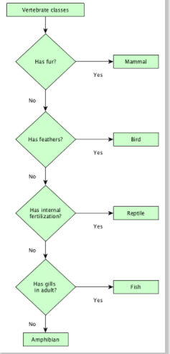

### Defining the Intents

Take a look at the Intents defined for this dichotomous key chatbot.

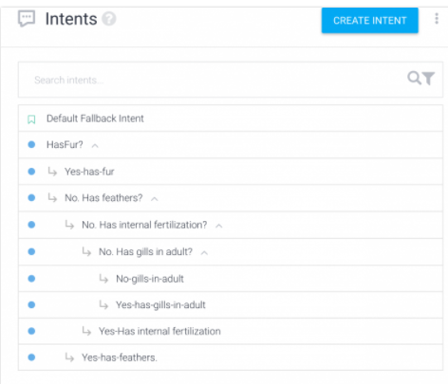

In other words, you can simply follow the tree like hierarchy and create corresponding intents for your bot.

Note: set the context lifespans to 1 for every autogenerated context. I have already written about it in a previous post, but I quite strongly believe that the [optimal lifespan value of a context you create is 1](http://miningbusinessdata.com/optimal-context-lifespan-in-api-ai/), and you should take the responsibility of managing the context state when the conversation goes off track. In my demo bot, I am not handling the case where the user goes off track, but with a little practice you can see that it wouldn’t be very hard to implement.

# Step by step guide to DialogFlow (API.AI) Part 19 – Creating the vending machine bot with follow up intents

[Table of Contents for Step by Step Guide](http://miningbusinessdata.com/step-by-step-guide-to-api-ai/)

If you remember, this is what the state diagram for the vending machine bot looked like.

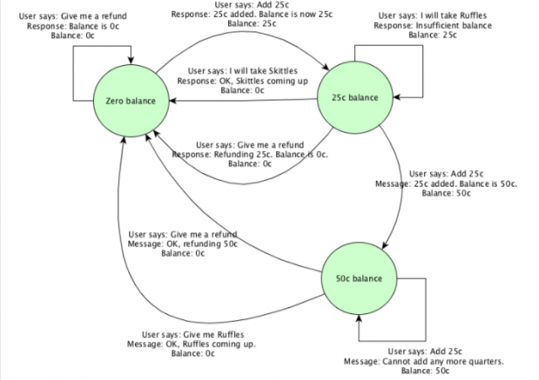

This is what the list of intents looks like for the old vending machine chatbot.

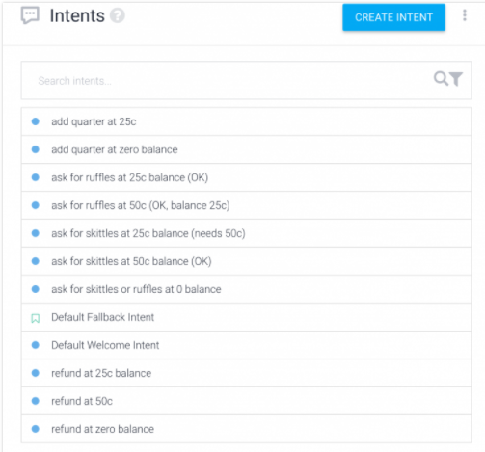

After rewriting the vending machine chatbot, this is what the list of intents look like.

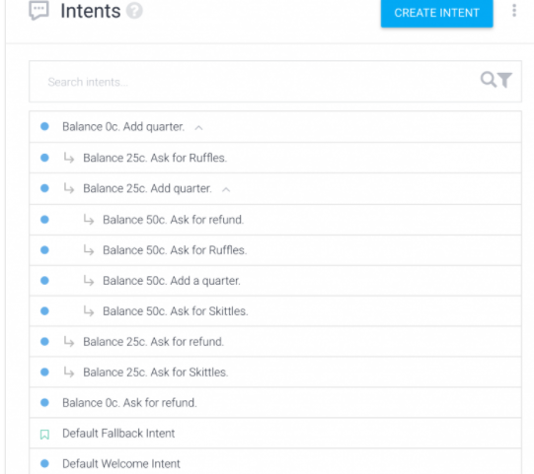

While the vending machine bot becomes easier to build using follow up intents, I have a couple of concerns with the way the follow up intents are implemented, under the hood

#### 1 Contexts are used to create the hierarchy

Once you look under the hood, you will see that DialogFlow still uses contexts to create the hierarchical structure. There is one huge benefit when doing this – everything is completely transparent. On the other hand, this also means you are still going to have to track what your contexts are doing (for e.g. don’t accidentally delete an autogenerated context, because that will remove the intent from the hierarchy).

#### 2 The existing naming conventions for the automatically generated contexts is not very user friendly

Look at these autogenerated context names as an example:

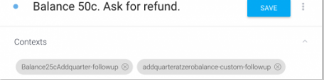

On the other hand, you cannot rename it into something more user friendly without going back and updating every other context. Which is quite a pain. Maybe DialogFlow must provide a way to rename contexts in place and have it reflect everywhere automatically.

# DialogFlow (API.AI) tutorial: Storing values in contexts

Did you know that the API.AI context can be used like a dictionary object which can hold a set of key-value pairs?

You can use this feature to refer to the value of an entity which was used in previous intents. Let us take a look at an example.

### Periodic Table Bot

The periodic Table Chatbot does something really simple. The user can ask for the atomic number, or the chemical symbol, or the color of any element in the periodic table. In addition, they can use the context (that is, remember the element they talked about in the previous message) and enquire about the other properties.

For example, here is a screenshot:

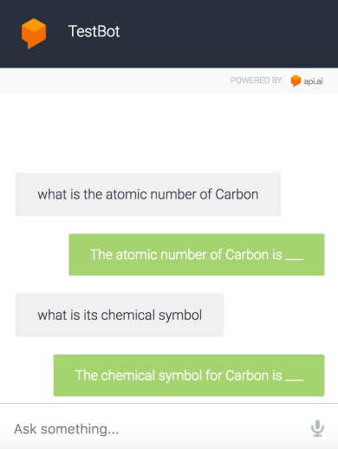

As you can see, the bot does not provide the actual values. To do that, we need to connect it to a webhook. I want to keep this example simple, so for now we will pretend that the webhook code will be wired up later to get the correct value.

(Update Aug 4 2017: I have written an article which explains [*how to fetch the data from a webhook*](http://miningbusinessdata.com/api-ai-tutorial-handling-multiple-intents-in-your-webhook/))

However, you should note that the bot

1. correctly identifies the element as Carbon in message 1
2. holds the value of the element in its memory for message 2

We will see how to do this.

### Declaring the entity

We will declare an entity called element. For now, I will just be hardcoding a few values into the element entity for the sake of demonstration. You can always use the CSV upload feature to add a complete list of elements into this entity.

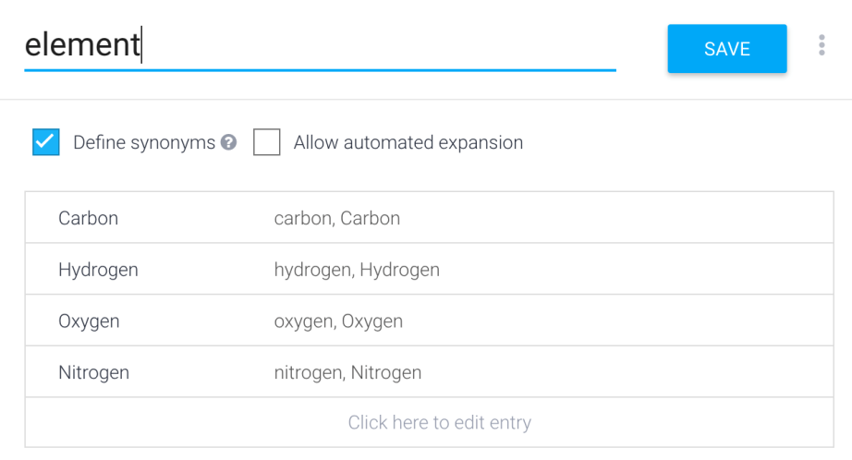

### Declaring the initial intent

Now we are ready to declare the intents.

The first intent is the GetAtomicNumber intent. Again, for the sake of demonstration and to keep it simple, I will simply use a single query for user says.

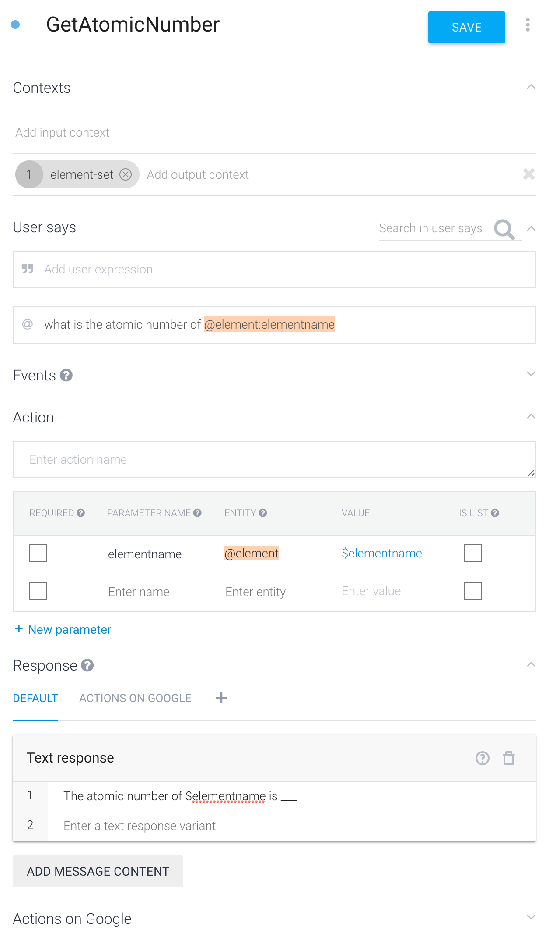

There are a few things to note in the declaration of this intent.

1. The output context is being set to element-set
2. The template mode is used to declare the element (this isn’t necessary. The example mode can also be used. But it adds some clarity to the example)
3. The name of the parameter is elementname
4. Which is used in the text response.

### Declaring the context based intents

Now we have set the context called element-set. This context holds a key-value pair, namely {elementname:Carbon}

(I am using Carbon as the example here. It could also be one of the other elements)

Let us see how we declare an intent which is context-driven and how it uses the value stored in the context.

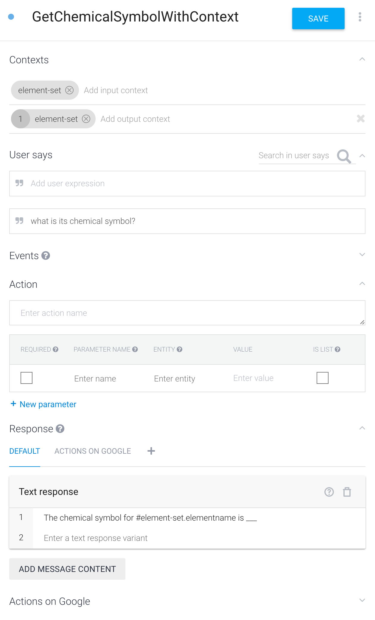

Note the following:

1. The input context is element-set*
2. We reset the context to be the same, with a lifespan of 1
3. We access the value stored in the context by using the following syntax: #context_name.parameter_name

*We don’t strictly need to use an input context for this intent. We can still access the value of the element-set context without adding it to the list of input contexts (if the element-set lifespan has not yet become zero). However, if you wish to improve your own reasoning of bot behavior, I suggest adding the input context explicitly as much as possible.

### Declaring all the intents

You can download the associated agent ZIP file if you are interested, but we will proceed to declare all the intents in a similar fashion. This is what the intents list will look like:

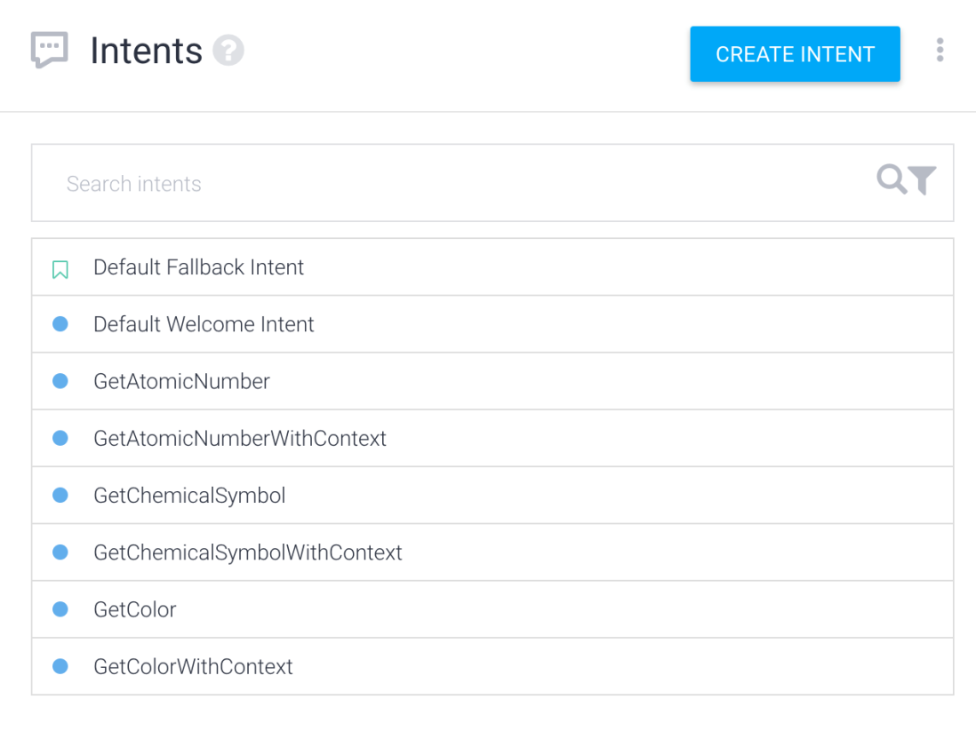

For each of the intent types (get atomic number, get chemical symbol, get color), we will have two intents – one with context, one without context. This will allow the user to start with any property, and hold the context to enquire about other properties.

Since we always propagate the context, in theory the user could keep asking the different properties repeatedly and always get the response. See the screenshot below for example.

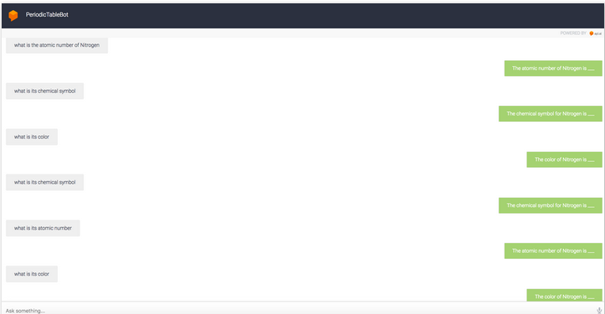

### A practical use case

Suppose you have a shopping bot where the user asks about a certain product. Once the bot identifies the product, the user is allowed to ask a series of questions about the same product (until they change it, or they stop). In such scenarios, the approach suggested above should work well.